ASYMPTOTES

An asymptote is a line that a curve approaches, as it heads towards infinity

3 basic types of Asymptotes:

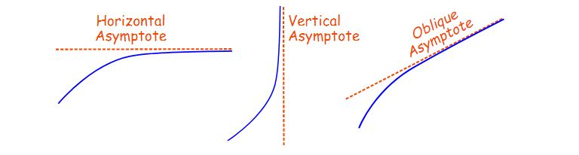

**Horizontal Asymptotes**

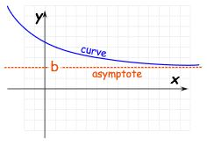

|  |  |
| --- | --- |
|  | It is a Horizontal Asymptote when:  as x goes to infinity (or −infinity) the curve approaches some constant value **b** |

## Vertical Asymptotes

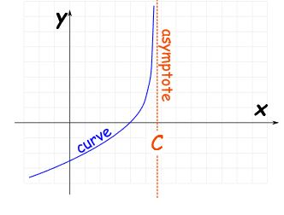

|  |  |
| --- | --- |
|  | It is a Vertical Asymptote when:  as x approaches some constant value **c** (from the left or right) then the curve goes towards infinity (or −infinity). |

## Oblique Asymptotes

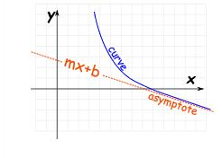

It is an Oblique Asymptote when:

as x goes to infinity (or −infinity) then the curve goes towards a line **y=mx+b**

(note: m is not zero as that is a Horizontal Asymptote).